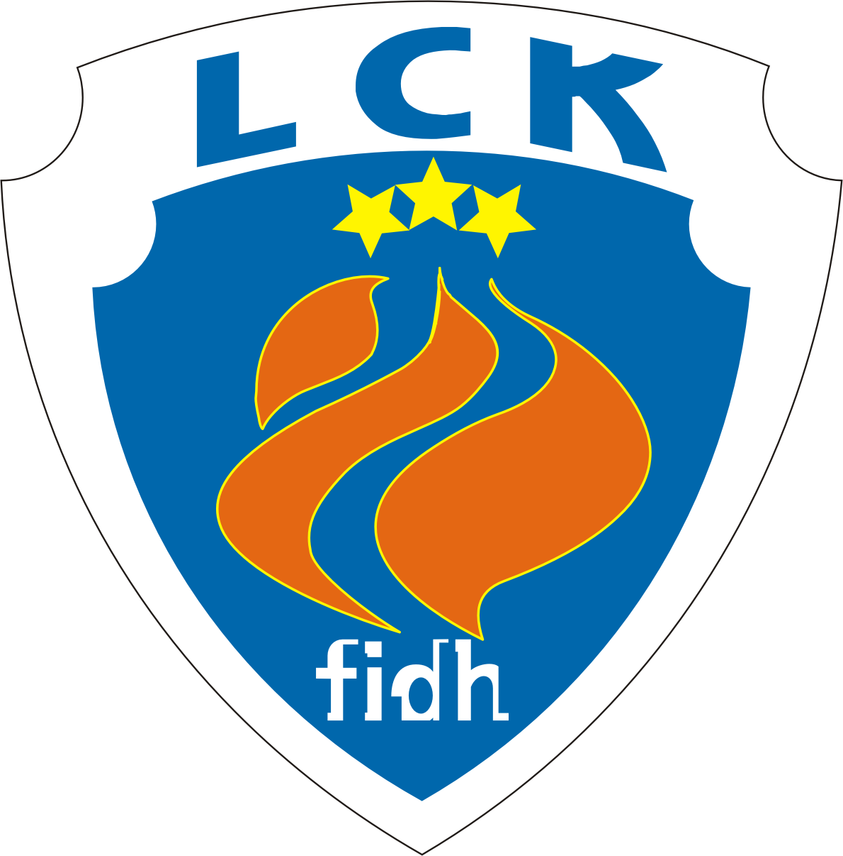
CLSF Latvijas Cilvēktiesību komiteja
F.I.D.H. Latvian Human Rights Committee
МФПЛ Латвийский комитет по правам человека
Reg. No. 40008010632, address: 102a-4, Dzirnavu str. Riga, LV-1050, Latvia. Phone (+371) 26420477 www.lhrc.lv lhrc@lhrc.lv

Statement
for the 110th session of the Human Rights Committee
in relation to the review of the Third periodic report of Latvia
March 10, 2014

I Statelessness: naturalization and scope of rights

The one specific issue, where Latvia, sadly, keeps the first place in Europe, is statelessness. As at January 1, 2014, more than 282,000 residents of Latvia (13.0 % of the population) are so-called “non-citizens” – lacking citizenship of any country and electoral rights even at the local level, although having permanent residence rights and, in more than 40 % of cases, born in Latvia. They are former citizens of USSR, who lived in Latvia before 1992, and their descendants.

The naturalization of “non-citizens” remains ineffective in abolishing statelessness – not more than 2500 people a year are naturalized (in 2009-2013). Even more disturbingly, hundreds of newborn children get this status every year. There are more than 8000 of stateless minors. While the total number of “non-citizens” among Latvian residents is decreasing (in 2013, by 15,007 people), most of the decrease is caused by death rate, emigration or obtaining citizenship of foreign countries, not naturalization in Latvia (1732 persons were naturalized in 2013; it is virtually impossible for all of them to be “non-citizens” before).

In a troubling way, a popular initiative to offer citizenship of Latvia to “non-citizens” without exams was stopped by the Central Election Commission in 2012, alleging that such a generous move would contradict the Constitution. This finding was confirmed on 12 February, 2014 by the Supreme Court.

Numerous limitations of the rights of non-citizens remain in force. Especially notable is the approach to calculating pensions for the time they worked in the other republics of the former USSR before 1991. It was evaluated as discriminatory in 2009 by the Grand Chamber of the European Court of Human Rights in Andrejeva v. Latvia, but the remedies offered are ex nunc only and do not apply to all of the victims.

II Linguistic rights in education

The most pressing concern with relation to linguistic discrimination and minority rights is connected with the attempts to abolish (already partial) instruction in minority languages in public education, save the subjects connected with the minorities’ identity. In January, 2014, drafting legislation for this aim, scheduled to be implemented by 2018, was included in the co-operation agreement between the political parties forming the new government. An attempt to switch all public kindergartens to Latvian as the only medium of instruction was rejected in the Parliament in May 2013, but only with 43 votes „against” and 2 abstentions – 41 votes, including most of the ruling parties, were cast „in favour” of moving the bill forward.

The network of minority schools (almost exclusively, those are public and already bilingual in their practice) is being gradually abolished. In 2002/2003, there were 280 minority schools and „dual stream schools” (one school providing both Latvian-language and bilingual - „minority” - education programmes, for different groups of pupils) in the country. In 2012/2013, there were only 173. The number of Latvian-language schools is decreasing, too, due to demographic issues, but much slower (respectively, there were 844 and 699 such schools, including „dual stream schools”). As a result, even partial education in minority languages became virtually unavailable in the smaller towns and rural areas of Western and Northern Latvia.
The tertiary education system does not provide schools with teachers specifically taught to teach in minority schools, using minority languages as language of instruction (except teachers of languages themselves).
In 2012, Section 41 of the Education Law was amended, depriving public minority schools of the right to choose their own models of use of languages of instruction in grades 1 to 9 (basic school). The models allowed by the government are rather various, but the current minister of education has announced an aim to achieve use of model No. 1 in most schools by 2018. It allows no more than 12 lessons a week (from 34) to be taught in a minority language or bilingually, by grade 9.
Starting with 2012, Latvian language and literature exam requirements in 12th grade of minority (bilingual) education programmes are the same as in Latvian-language schools. The lack of distinction between pupils learning in Latvian only and bilingually, in the present situation, may amount to discrimination, influencing pupils’ chances to receive post-secondary education.

